**Model validation outputs**:

Call:

glm(formula = Responder ~ as.factor(Attrgrp6) + as.factor(Attrgrp7) +

as.factor(Attrgrp9) + as.factor(Attrgrp10), family = binomial("logit"),

data = cust_data)

Deviance Residuals:

Min 1Q Median 3Q Max

-2.6688 -0.1138 -0.0487 0.2400 3.6706

Coefficients:

Estimate Std. Error z value Pr(>|z|)

(Intercept) 1.53276 0.10400 14.738 < 2e-16 ***

as.factor(Attrgrp6)2 -0.78665 0.07710 -10.202 < 2e-16 ***

as.factor(Attrgrp6)3 1.99979 0.18002 11.109 < 2e-16 ***

as.factor(Attrgrp7)2 -0.71768 0.07504 -9.564 < 2e-16 ***

as.factor(Attrgrp7)3 -6.26737 0.71133 -8.811 < 2e-16 ***

as.factor(Attrgrp9)2 -0.71815 0.07520 -9.550 < 2e-16 ***

as.factor(Attrgrp9)3 -5.46137 0.45823 -11.919 < 2e-16 ***

as.factor(Attrgrp10)2 -0.30191 0.08940 -3.377 0.000733 ***

as.factor(Attrgrp10)3 -1.04081 0.12876 -8.084 6.29e-16 ***

as.factor(Attrgrp10)4 -6.04590 0.39083 -15.469 < 2e-16 ***

---

Signif. codes: 0 ‘***’ 0.001 ‘**’ 0.01 ‘*’ 0.05 ‘.’ 0.1 ‘ ’ 1

(Dispersion parameter for binomial family taken to be 1)

Null deviance: 9001.8 on 7999 degrees of freedom

Residual deviance: 4236.9 on 7990 degrees of freedom

AIC: 4256.9

Number of Fisher Scoring iterations: 9

**Hosmer lemeshow –goodness of fit test:**

hosmerlem(y, yhat)

X^2 Df P(>Chi)

4.2916977 8.0000000 0.8298933

Ensure p value is higher than 0.05

Lift chart:

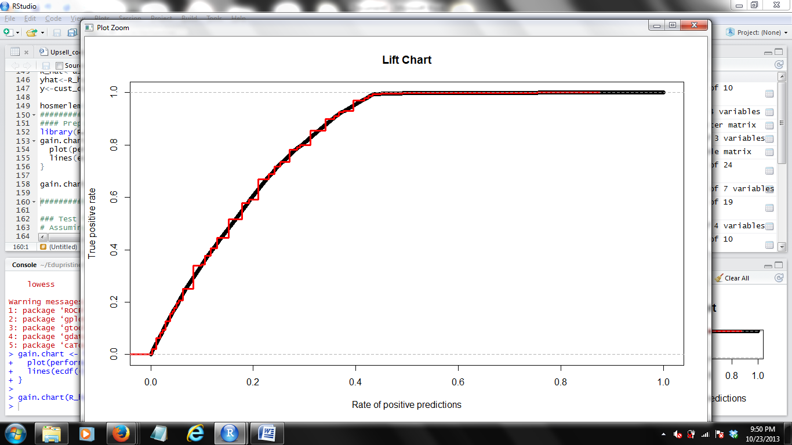

**Concordance value to calculate Gini coeficient:**

$concordance

[1] 0.9110889

$num_concordant

[1] 1824

$discordance

[1] 0.08141858

$num_discordant

[1] 163

$tie_rate

[1] 0.007492507

$num_tied

[1] 15